# Assignment 1 (Rev B)

1. Relationships – For this question you are to ignore attributes and provide ER diagrams that represent the relationship between entities correctly. The entities will be Foo, Bar and Baz. (there should be one diagram for part a, and one diagram for part b).  
   1. A Foo is related to at least one Bar.  
      A Bar is related to at most one Foo.



* 1. A Foo is related to no more than one Bar.  
     A Bar is related to zero or more Foos.  
     A Baz is related to one or more Bars and at least one Foo.  
     A Bar is related to at least one Baz.   
     A Foo is related to exactly one Baz.

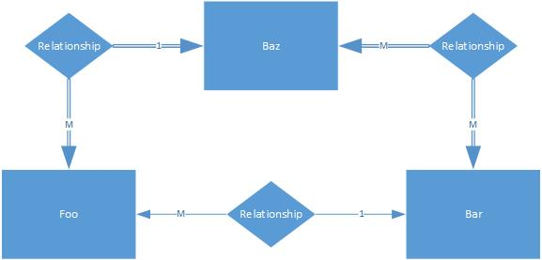

1. Provide a Schema for the following ER Diagram.  
   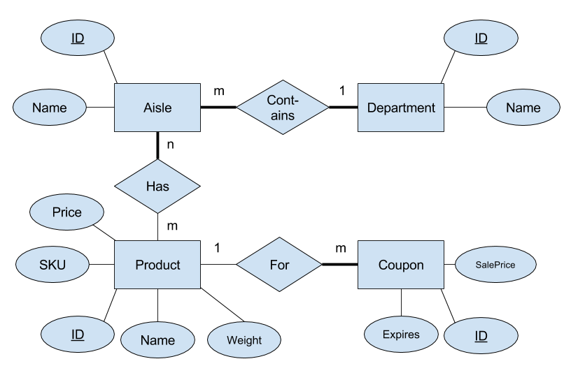



1. Provide an ER diagram for the following situation. You run an advertising firm, and you want to implement a database that represents the following description of your business.  
   You sell advertisements.
   1. An advertisements has an id, name and price.
   2. Advertisements have different types.
   3. Each advertisements type has id, media type and target audience.
   4. An advertisement belongs to exactly one advertisement type.
   5. An advertisement type can host many different advertisements.
   6. An advertisement can be show on many different media providers.
   7. A media provider show zero or more advertisements.
   8. A media providers can own other media providers. For example, Disney and abc are both media providers, but Disney owns abc.
   9. Each media provider has an ID and audience size.
   10. There are customers and purchases.
   11. Each customer has an id, name, and state.
   12. Each purchase has id, date and total cost.
   13. A customer makes at least one purchase.
   14. A purchase is made by exactly one customer.
   15. A purchase consists of one or more advertisements.
   16. An advertisement can be in zero or more purchases.
   17. The number of times an advertisement will run is stored with each purchase.

